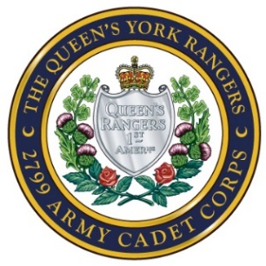
Queen’s York Rangers 2799 Army Cadet Corps
John Graves Simcoe Armoury
215 Industrial Parkway South
Aurora ON L4G 3V5
www.rangers2799.com

APPLICATION FOR MEMBERSHIP IN THE CANADIAN ARMY CADETS

Dear Parent/Guardian:
Thank you for your interest in enrolling your son/daughter/ward in the Queen’s York Rangers 2799 Army Cadet Corps.
Please print and complete the enclosed or online Application for Membership in the Canadian Army Cadets form, sign (including your cadet’s signature where required) and return them as soon as possible along with the following forms and items:

- Copy of the youth's Birth Certificate or Permanent Residence or Canadian Passport
- Copy of the youth's Ontario Health Card
- Recent small photo of applicant with their first and last name printed on the back
- Recruitment Information
- Transportation Permission Form
- Acknowledgement Section of the Cadet Code of Conduct
- Acknowledgement Section of the Cadet Pledge of Commitment
- Support Committee Questionnaire

Please also include on the application form a valid email for the cadet. We would also appreciate a valid address for the parents as well.

If you have any questions or concerns, please visit our website at www.Rangers2799.com, join our Facebook Group at Friends of the Queen's York Rangers 2799 Army Cadet Corps, email us at 2799army@cadets.gc.ca or phone us at 905-726-8600
Sincerely,
Administration Officer
Queen’s York Rangers 2799 Army Cadet Corps

