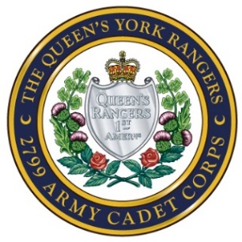
Queen’s York Rangers 2799 Army Cadet Corps
John Graves Simcoe Armoury
215 Industrial Parkway South
Aurora ON L4G 3V5
www.rangers2799.com

CADET CODE OF CONDUCT

While accountable for my conduct to the Commanding Officer of the Queen’s York Rangers 2799 Army Cadet Corps, I agree to the following:

OBEDIENCE
To obey all lawful orders and regulations

SAFETY
To no endanger my fellow cadets’ safety

RESPECT
To treat my fellow cadets, officers and CI’s with respect

COARSE LANGUAGE AND BEHAVIOUR
Never to fight, bully, swear at or shout at anyone

PROPERTY
To treat all personal property, including DND and League property with the utmost respect

ENVIRONMENT
To treat the environment with respect by not littering, damaging, or destroying it, whether I be in public or personal property

THEFT
To never take anyone’s property without their permission

UNLAWFUL MATERIALS
To never buy, sell, distribute or participate in the use of alcohol, tobacco products, pornography or drugs while on cadet time

FRATERNIZATION
To not participate in intimate relationships while on cadet time, including weekend exercises, fire piquets, March Break trips or competitions

DRESS AND DEPORTMENT
To always obey all dress and grooming regulations

PROPERTY
To treat all personal property, including DND and League property with the utmost respect. Be responsible for your own property and ensure it is safe or left at home.

Any breach of the Code of Conduct may result in administrative or disciplinary action

________________________________ ____________________________
PRINT NAME CO or Delegate

________________________________ ____________________________
SIGNATURE DATE

