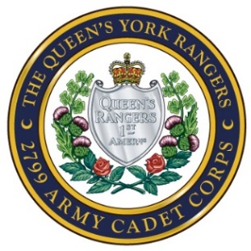
Queen’s York Rangers 2799 Army Cadet Corps
John Graves Simcoe Armoury
215 Industrial Parkway South
Aurora ON L4G 3V5
www.rangers2799.com

QUEEN’S YORK RANGERS 2799 ARMY CADET CORPS PLEDGE OF COMMITMENT

I, the undersigned, being a cadet in the Queen’s York Rangers 2799 Army Cadet Corps, understand that I have a responsibility to attend as many parade nights, weekend exercises and special events as possible in order to make this Corps the success that it is. There are two days of the year for which I need to attend without fail. The first being the Remembrance Day Parades, which honours both our fallen and our veterans who have sacrificed so much for all Canadians. The second day is our Annual Ceremonial Review Parade that is normally held on the first Saturday in June, which is a day we demonstrate to our family, friends, community leaders and military dignitaries what a year of hard work looks like in the form of a parade, demonstrations and displays.

For the 2021/2022 cadet training year;

- Tagging Weekends – One in the fall, one in spring
- Remembrance Day - November 7th, 2021
- Christmas Mess - December 10, 2021
- Annual June 4, 2022

I understand that if I do not show up for these days unless I have submitted a valid written reason at least two weeks ahead of time, then I will be held accountable, will be counselled by the Commanding Officer and will NOT be permitted to attend summer camp.

Parents will be made aware of these dates through the Corps website, Facebook group, Weekly All Call and newsletters well ahead of time.

_____________________________________ _______________________________
CADET NAME PRINT COMMANDING OFFICER’S SIGNATURE

_____________________________________ _______________________________
CADET SIGNATURE DATE

